

# Accessible Toilets Guide

For visitors to the Galleries

Accessible Toilets Guide 1

Finding the nearest facilities: maps 2

Nearest right-hand transfer toilets 3

Outside ladies’ bathroom (Parkinson Court, Basement) 3

Outside mens’ bathroom (Parkinson Court, Basement) 5

Nearest left-hand transfer toilet 6

On corridor to Michael Sadler Building (Parkinson Court, Ground Floor) 6

Nearest Changing Places toilet 8

Finding the facilities 8

Dimensions and description 11

## Finding the nearest facilities: maps

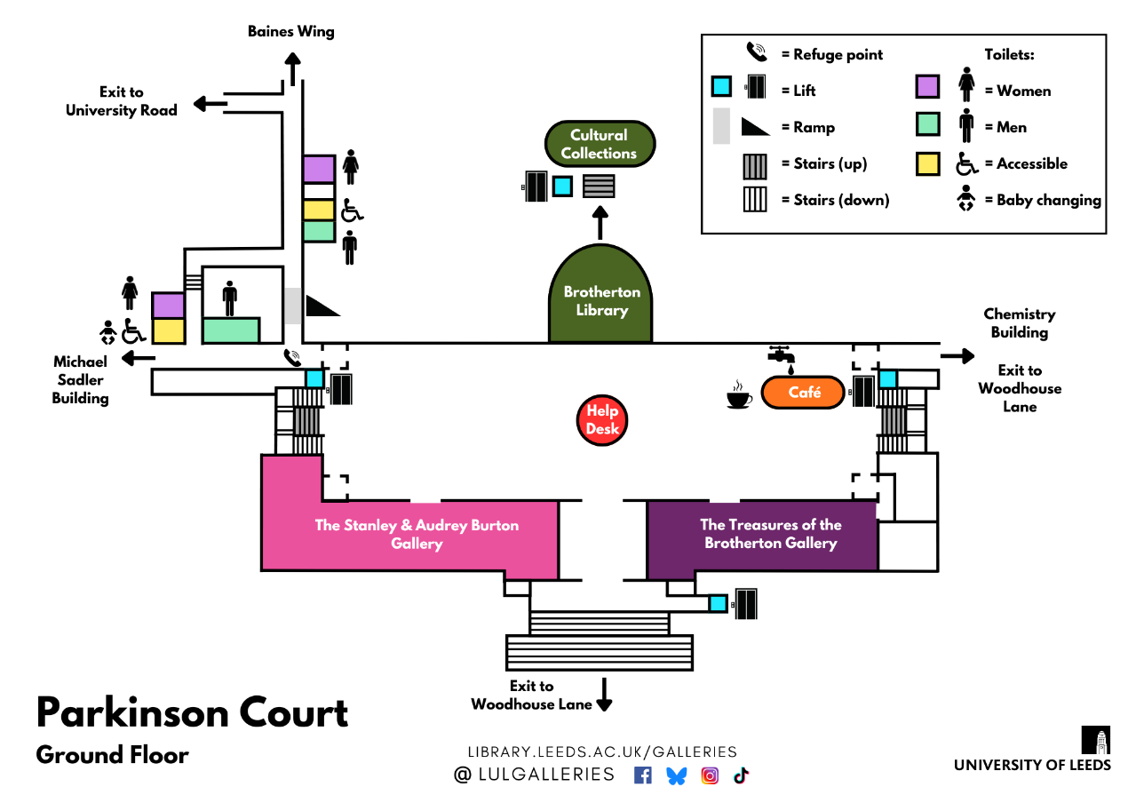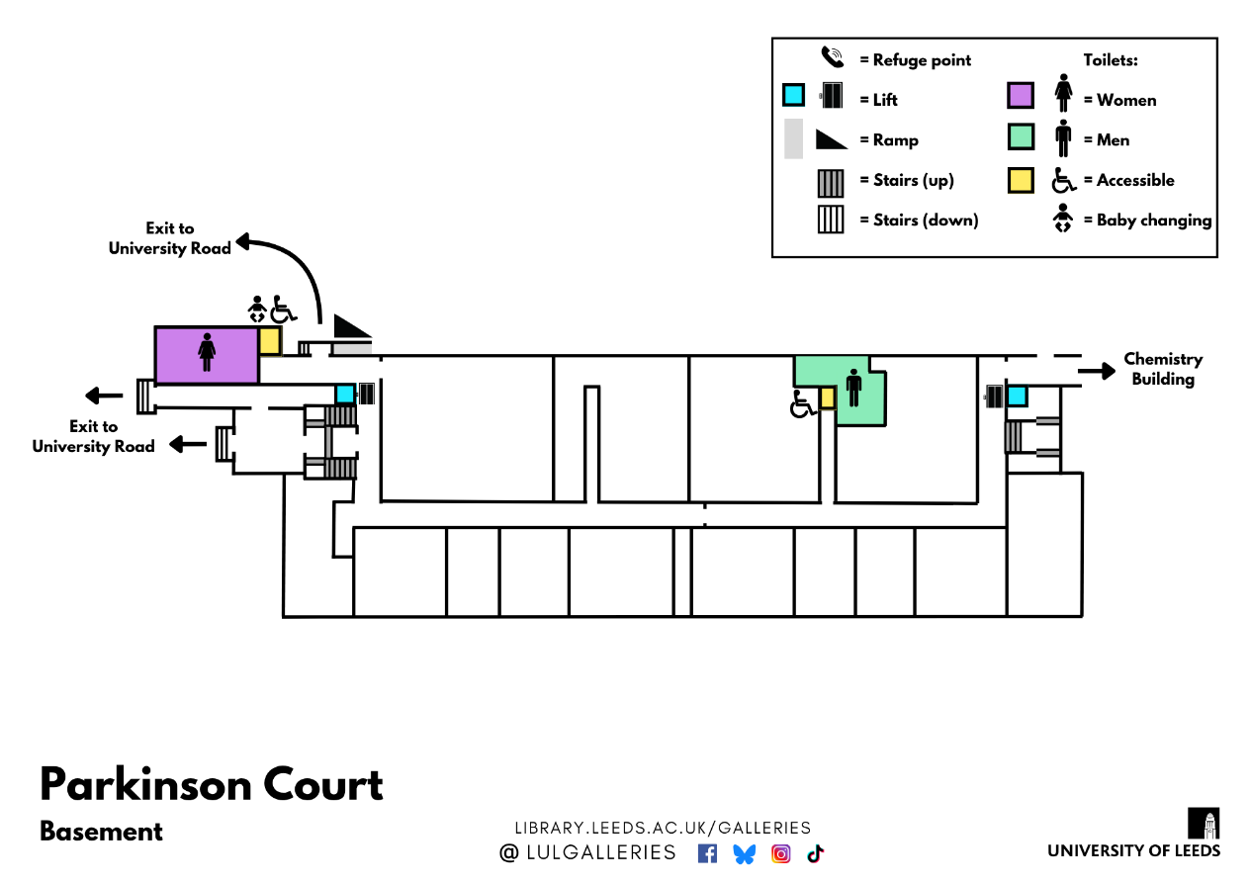

## Nearest right-hand transfer toilets

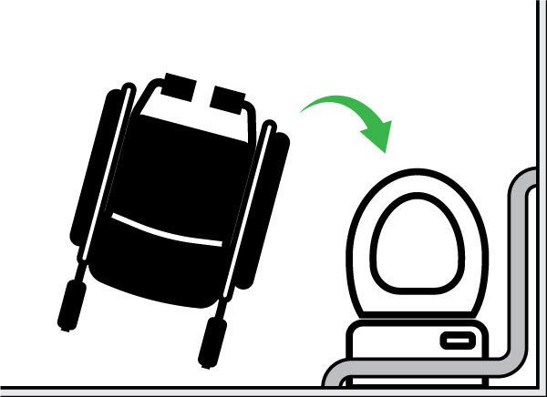

There are two wheelchair accessible toilets in the Basement of Parkinson Building with step-free access via lift.

They are both right-hand transfer. These are the nearest public WCs to the Galleries.

### Outside ladies’ bathroom (Parkinson Court, Basement)

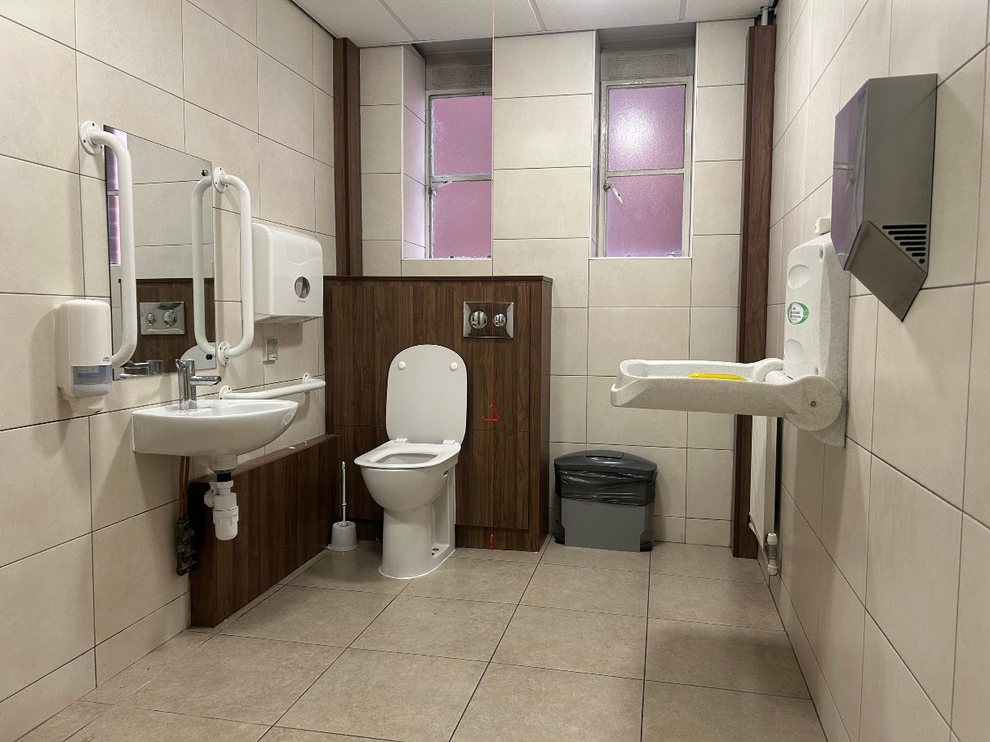

There is one self-contained accessible unisex bathroom next to the ladies' bathrooms. It is the larger of two public accessible toilets in the Parkinson Building. It also contains baby-changing facilities. You do not need a Radar key.

The toilet is accessible by lift with no steps or ramps.

The door has visual signage, of two baby-changing and wheelchair icons. A sign also reads ‘Gender Neutral Toilet’.

The doorway of the accessible toilet is approximately 910mm wide. The door handle lifts up to lock.

The toilet is right-hand transfer. There is a clear space to one side of at least 1100mm. The height of the accessible toilet is approximately 470mm high.

There is a sanitary disposal bin next to the toilet. The flush is operated with a push button, approximately 1020mm high.

There is a horizontal grab rail mounted on the wall next to the toilet (740mm high). There are two vertical grab rails mounted on either side of the sink (900mm high). There are two horizontal grab rails on either side of the door (1020mm and 1150mm high).

The sink is approximately 750mm high. There is a left-to-right lever tap. There is an automatic hand dryer only, approximately 1100mm high.

The bathroom also contains baby-changing facilities. These fold down from 1320mm high, at a height of approximately 900mm.

The toilet is brightly lit with automatic ceiling spotlights.

In case of emergency, all accessible toilets have red alarm cords. The alarm reset button is on the wall next to the toilet, approximately 900mm high.

### Outside mens’ bathroom (Parkinson Court, Basement)

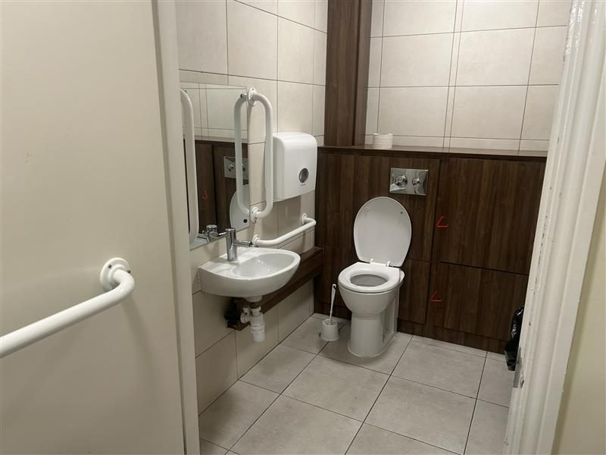

There is one self-contained accessible unisex bathroom next to the gents' bathrooms. It is the smaller of two public accessible toilets in the Parkinson Building. It does not contain baby-changing facilities. You do not need a Radar key.

The toilet is accessible by lift with no steps or ramps.

The door has visual signage, of one wheelchair icon. There is no written signage.

The doorway of the accessible toilet is approximately 910mm wide. The door handle lifts up to lock.

The toilet is right-hand transfer. There is a clear space to one side of at least 700mm. The height of the accessible toilet is approximately 470mm high.

There is a sanitary disposal bin next to the toilet. The flush is operated with a push button, approximately 1020mm high.

There is a horizontal grab rail mounted on the wall next to the toilet (740mm high). There are two vertical grab rails mounted on either side of the sink (900mm high). There are two horizontal grab rail on the inside of the door (1020mm high).

The sink is approximately 750mm high. There is a left-to-right lever tap. There is an automatic hand dryer only, approximately 950mm high.

The toilet is brightly lit with automatic ceiling spotlights.

In case of emergency, all accessible toilets have red alarm cords. The alarm reset button is on the wall opposite the toilet, approximately 1110mm high.

## Nearest left-hand transfer toilet

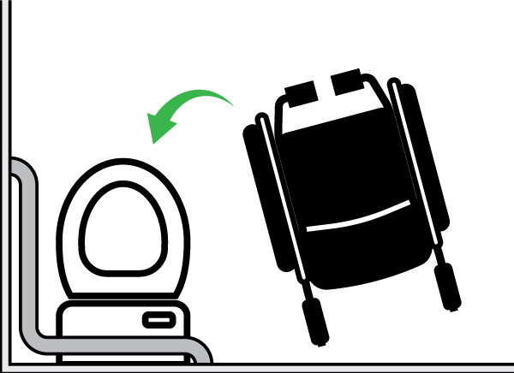

There is a gender-neutral wheelchair-accessible bathroom on the Ground Floor of Parkinson Building with step-free access.

This is the nearest left-hand transfer public WC to the Galleries.

### On corridor to Michael Sadler Building (Parkinson Court, Ground Floor)

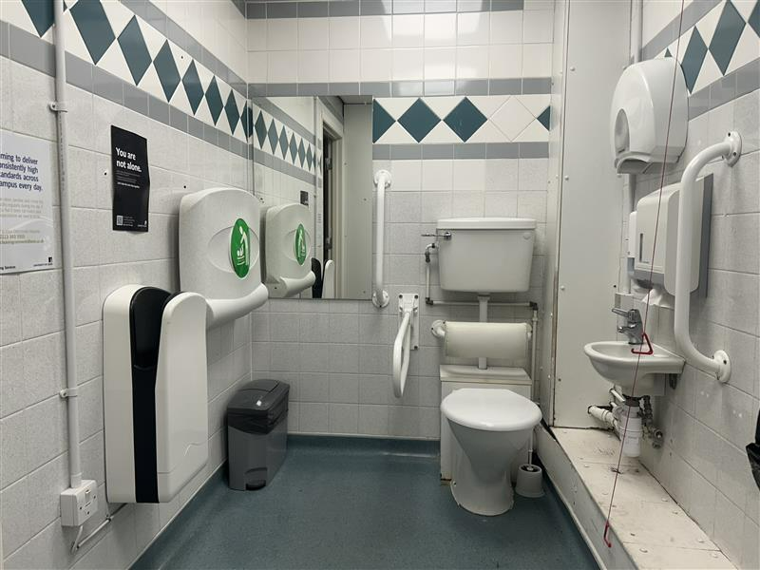

The bathroom is self-contained. It also contains baby-changing facilities. You do not need a Radar key.

The toilet is accessible with no steps or ramps.

The door has visual signage, of one wheelchair, baby-changing and all-gender icons. There is no written signage.

The doorway of the accessible toilet is approximately 900mm wide. The door handle lifts up to lock.

The toilet is left-hand transfer. There is a clear space to one side of at least 700mm. The height of the accessible toilet is approximately 450mm high.

There is a sanitary disposal bin next to the toilet. The flush is operated with a lever, approximately 1150mm high.

There is a drop-down horizontal grab rail to the right of the toilet. When lowered, two parts are 500mm and 700mm high. There is one vertical grab rail mounted on the right side of the sink (800mm to 1400mm high). There are two horizontal grab rails on each side of the door (1100mm and 1050mm high).

The sink is approximately 750mm high. There is a left-to-right lever tap. There is an automatic hand dryer, approximately 950mm high. There is also a paper towel dispenser above the sink (1000mm high).

The bathroom also contains baby-changing facilities. These fold down from 1320mm high, at a height of approximately 900mm.

The toilet is brightly lit with automatic ceiling spotlights.

In case of emergency, all accessible toilets have red alarm cords. The alarm reset button is on the wall next to the toilet, approximately 900mm high.

## Nearest Changing Places toilet

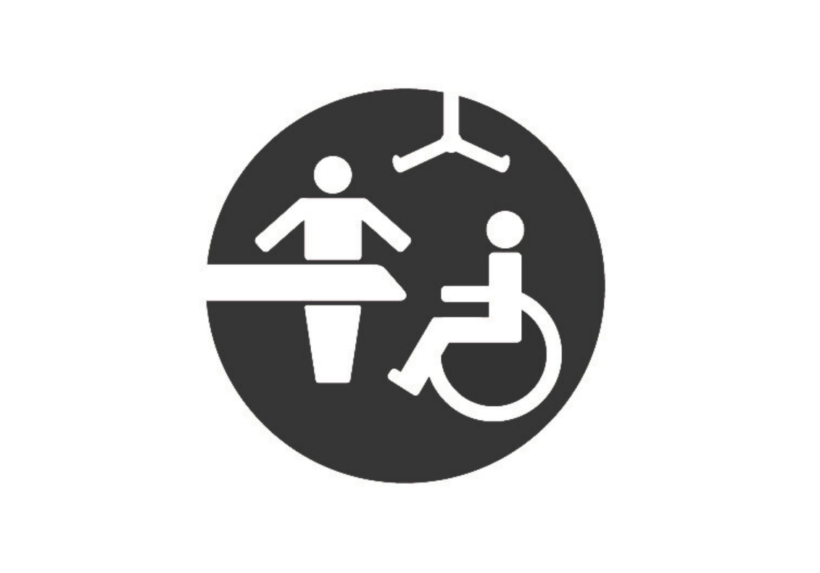

The nearest Changing Places equivalent bathroom is in the Laidlaw Library (5 minute walk).

Enter the Ground Floor on Blenheim Terrace for step-free access.

[View this Changing Places toilet on AccessAble](https://www.accessable.co.uk/university-of-leeds/access-guides/laidlaw-library)

### Finding the facilities

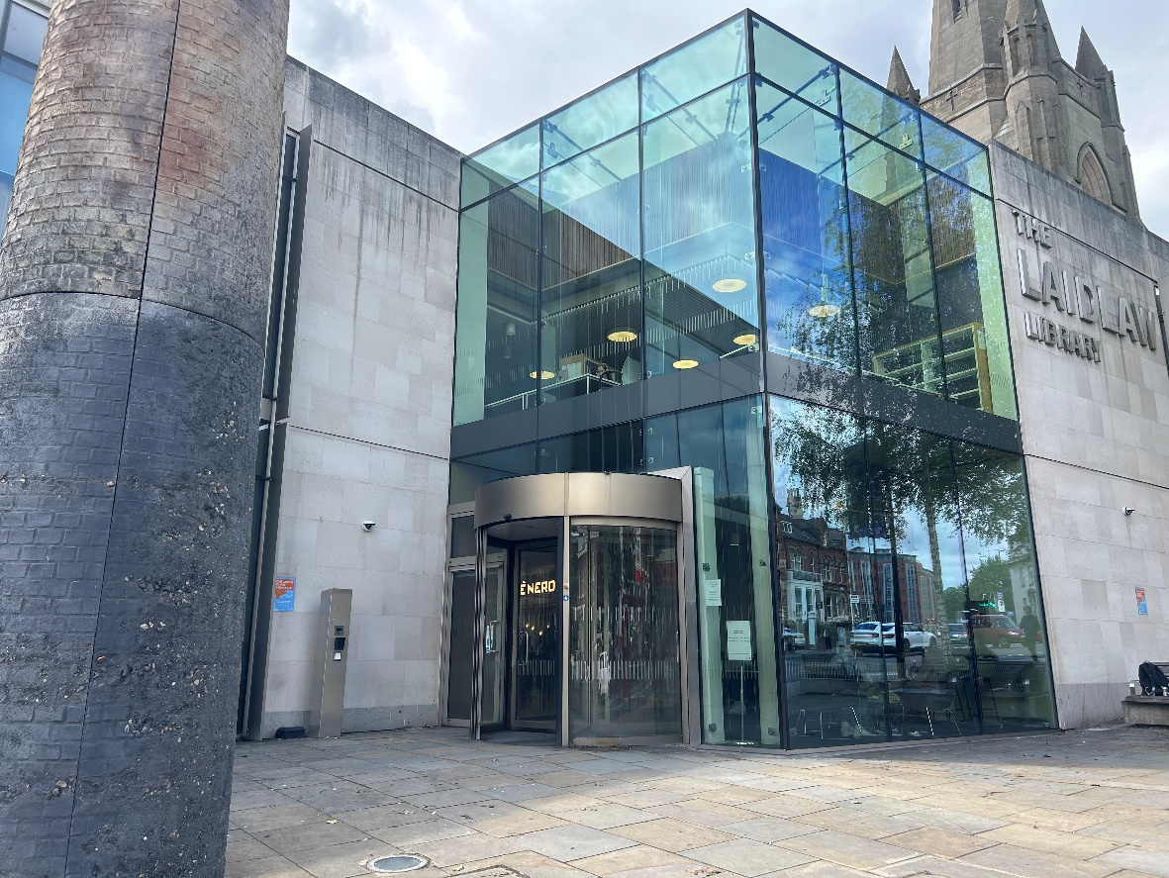

Enter via the step-free entrance on Blenheim Terrace.

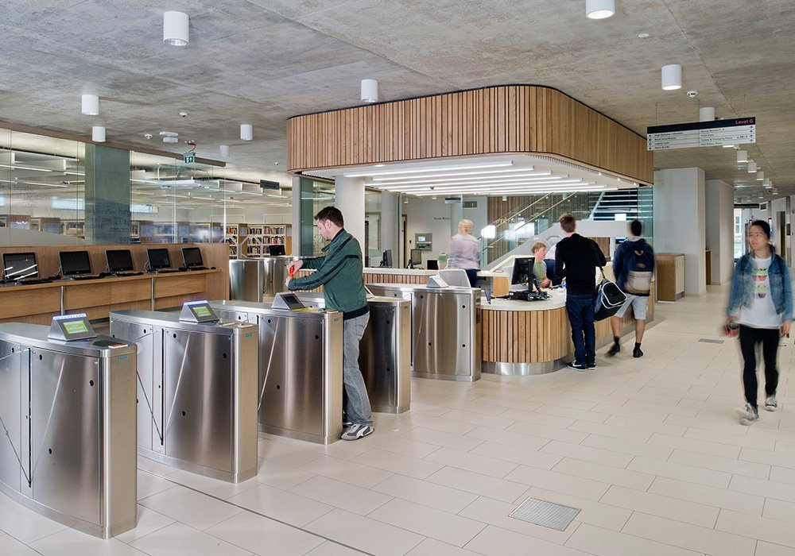

Carry on past the café, reception, and study area on the same floor. Head towards the ‘Print Zone’.

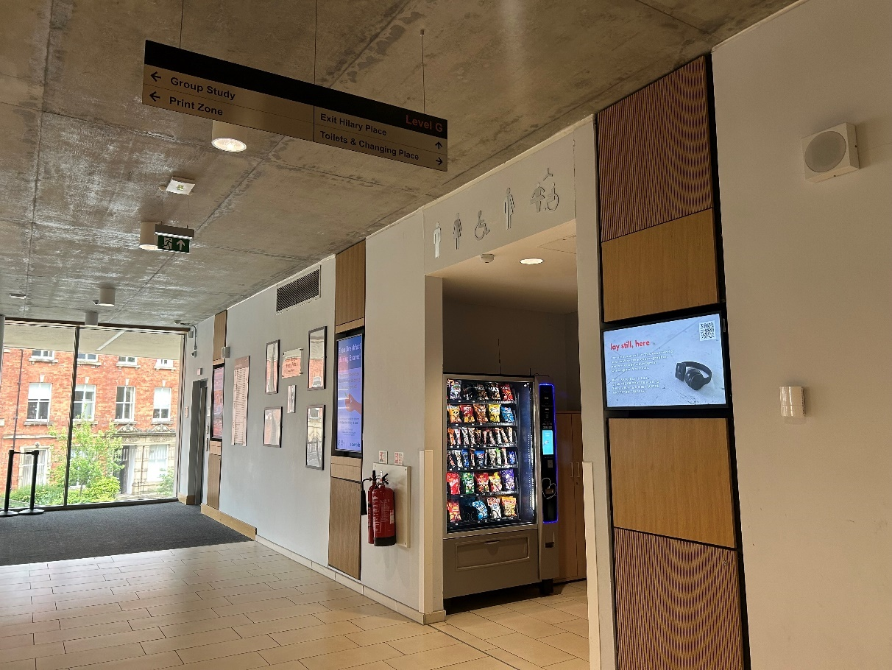

Turn right at the sign to ‘Toilets & Changing Place’.

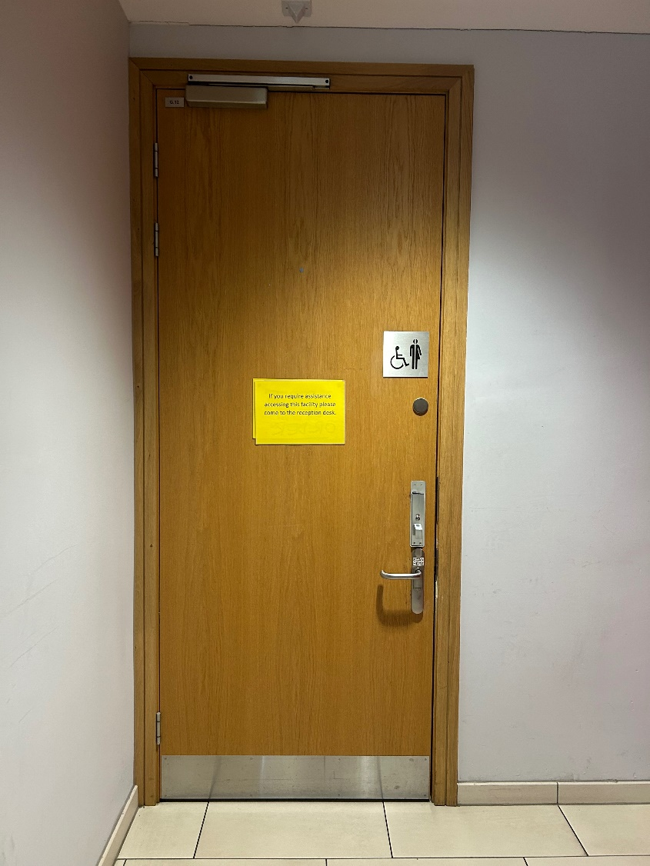

Straight ahead you will see a gender-neutral, accessible toilet.

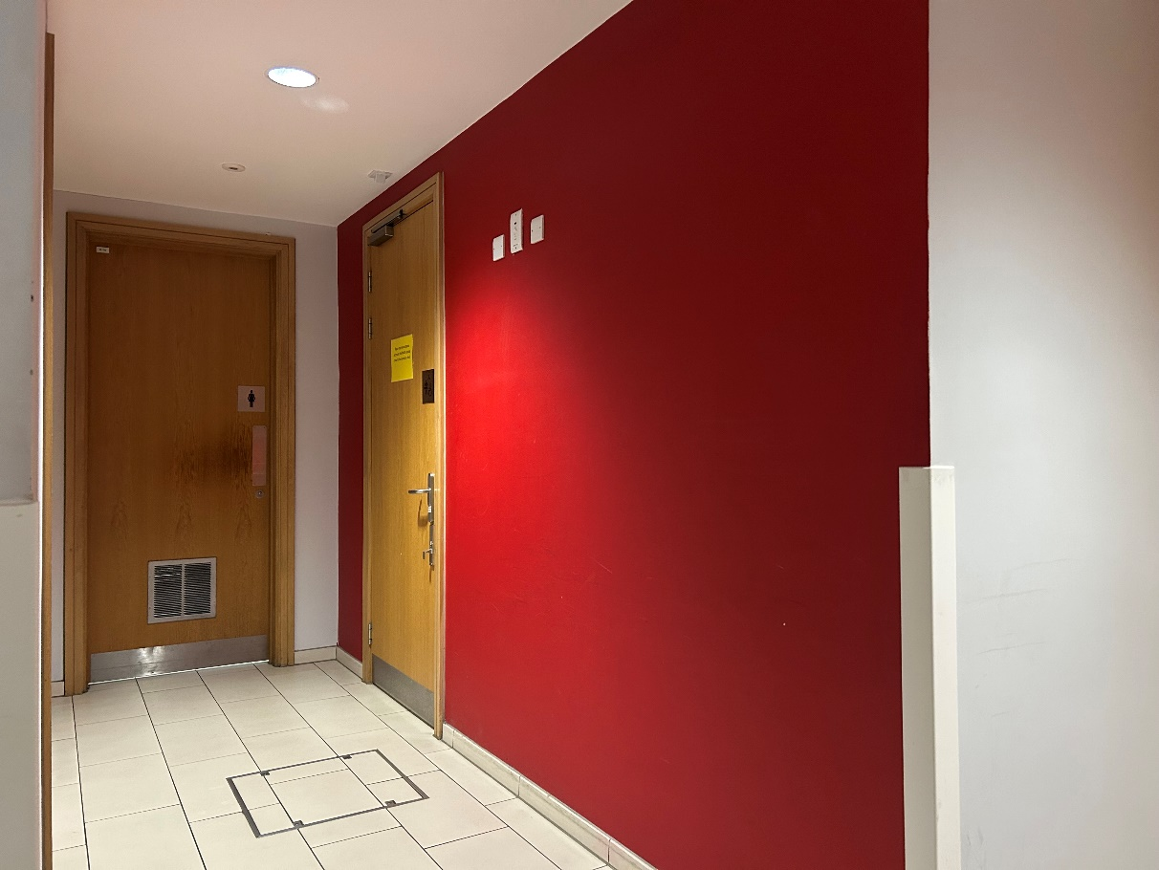

Turn left to find the Changing Places toilet, next to the ladies’ bathroom.

### Dimensions and description

The toilet in Laidlaw Library meets the equivalent of Changing Places standards.

It is a self-contained, accessible bathroom. It is the larger of two accessible bathrooms on the Ground Floor of Laidlaw Library. It is approximately 12 square metres.

You do not need a Radar key, but you do need to ask a member of staff for access. Find the Library Customer Services team at the Reception desk on the Ground Floor.

The toilet is accessible with no steps or ramps, through the level access entrance on Blenheim Terrace.

The door has visual signage of a Changing Places icon.

The doorway is approximately 900mm wide. The door handle lifts up to lock.

There is a shower with two drop-down seats (470mm high). There are two drop-down horizontal grab rails, and two fixed horizontal grab rails, approximately 670mm high. There is a fixed vertical grab rail to the left of the shower (800mm – 1400mm high).

There is a changing bench with two grab rails. The height of the bench is fixed (800mm high). The length of the facility changing bench is 1850mm. It has wheels and can be moved.

There is a ceiling track hoist. The height of the hoist is electrically operated with push buttons on a grey remote. The position of the hoist is manually operated by pulling. The hoist covers all areas of the cubicle.

The toilet is left- and right-hand transfer. There is a clear space for left-hand transfer of at least 550mm. There is a clear space for right hand transfer of at least 1200mm.

The height of the toilet is adjustable. It can move from 470mm to 750mm high. It is electrically operated with a push button on the left grab rail.

There are two drop-down horizontal grab rails on both sides of the toilet (700mm - 980mm high). The flush is operated with a push button on both sides (750mm – 1030mm high).

The height of the sink is adjustable. It is electrically operated with push buttons on a black remote. There is a clear space below the sink bowl. There are two lever taps.

There is an automatic hand dryer, approximately 840mm high. There are also paper towels, with no dispenser.

There are two bins, for sanitary and waste disposal.

The toilet is brightly lit with automatic ceiling spotlights.

In case of emergency, there are two red alarm cords. One is to the left of the toilet. Another is to the left of the shower. Two alarm reset buttons are on the walls, approximately 1100mm high.