

# Visual Story

For visitors to the Galleries



Contents

Visual Story 1

Introduction to the Gallery 3

Sensory information 5

Sensory map 8

Finding the Gallery 9

Map of Parkinson Building 13

When you arrive 14

Rules in the Gallery 16

Things you can do in the Gallery 18

What will you see? 19

What can you borrow? 21

Seating 24

Eating and drinking 26

Finding the bathrooms 28

Accessible bathrooms 31

If you hear the fire alarm 33

Shop 34

Leaving the Gallery 35

Contact us 36

## Introduction to the Gallery

|  |  |
| --- | --- |
| The Stanley & Audrey Burton Gallery is an **art gallery**.  It is part of the University of Leeds. | Groups of people stood in a white walled art gallery. There are paintings on the walls, and a sculpture in a glass case. |
| Entry to the Gallery is free.  Anyone can visit. It is open to the public.  You do not need to book a ticket. Just walk in. | Two black graphics on a white background. On the left is a pound sign in a circle with a line through it. On the right is two admission tickets in a circle with a line through it. |
| It is open:  Tuesday  Wednesday  Thursday  Friday  Saturday | Graphic of a page from a wall calendar with a red top and black writing which reads Tuesday - Saturday, on a grey background. |
| It is closed:  Sunday  Monday  and some holidays.  You can check these dates online, or call us. | Graphic of a page from a wall calendar with a red top and black writing which reads Sunday - Monday, on a grey background. The whole image has a black line through it. |
| It is open from 10.00am to 5.00pm. | Two black graphics of clock faces on a grey background. The arrow hands on the clock on the left show ten o'clock. The arrow hands on the clock on the right show five o'clock. |
| You can find more information  on our website  on our social media  by telephone  by email  by asking a member of staff | Black graphic of two overlapping speech bubbles, one with three dots inside and one with a question mark inside, on a white background. |

## Sensory information

|  |  |
| --- | --- |
| The Gallery is usually quiet.  There might be groups or families visiting.  There are fewer visitors at the start and end of the day. | Black graphic of three standing people close together, on a grey backgroun. |
| Sometimes there are events in the Gallery.  This can be busy with big crowds and noise.  You can call us on 0113 343 2778 to find out how busy the gallery may be. | Black graphic of a circle of eight standing people on a white background. |
| Sometimes there will be sound in the Gallery.  This could be music or sound from a video.  You can borrow ear defenders, or avoid areas marked on the sensory map. | Black graphic of a loudspeaker with three curved noise lines, one a grey background. |
| The Gallery is brightly lit.  The walls are white, and the lights are artificial. | Photograph of the inside of a white walled gallery room. Around the walls of the room are artworks hung in white frames. In the back corner of the room is a tall thin sculpture standing on a white plinth. The floor is wooden laminate. |
| There may be screens with bright or moving images.  There will be signs if there any flashing lights. | Photograph of a black digital tablet in a black case, showing a geometric shape on the screen, mounted onto a white wall. |
| There is a hearing loop in the Gallery.  Switch to the ‘T’ position.  We can provide Wi-Fi access. | White graphic of an ear with a diagonal line through it and the letter Y, on a blue background. |
| The Parkinson Court is used for University events.  This can be busy with big crowds and noise. | Photograph of the interior of a tall large building with stone collumns around the walls, and a grand staircase at the back. In the middle of the room is a person dancing, with a crowd of people stood and sat around watching. |
| In the entrance to the Parkinson Building, there is a piano that people can play.  This can be noisy as you walk through to the Gallery. | Photograph of a colourfully decorated, wooden upright piano and black piano stool. |
| You can borrow sensory items to use in the Gallery.  Please use the space how it is comfortable for you. | Photograph of a person in a green jumper wearing pink ear defenders. They are stood infront of a wooden pegboard and are holding a green and white rubber fidget toy in their right hand. |

## Sensory map

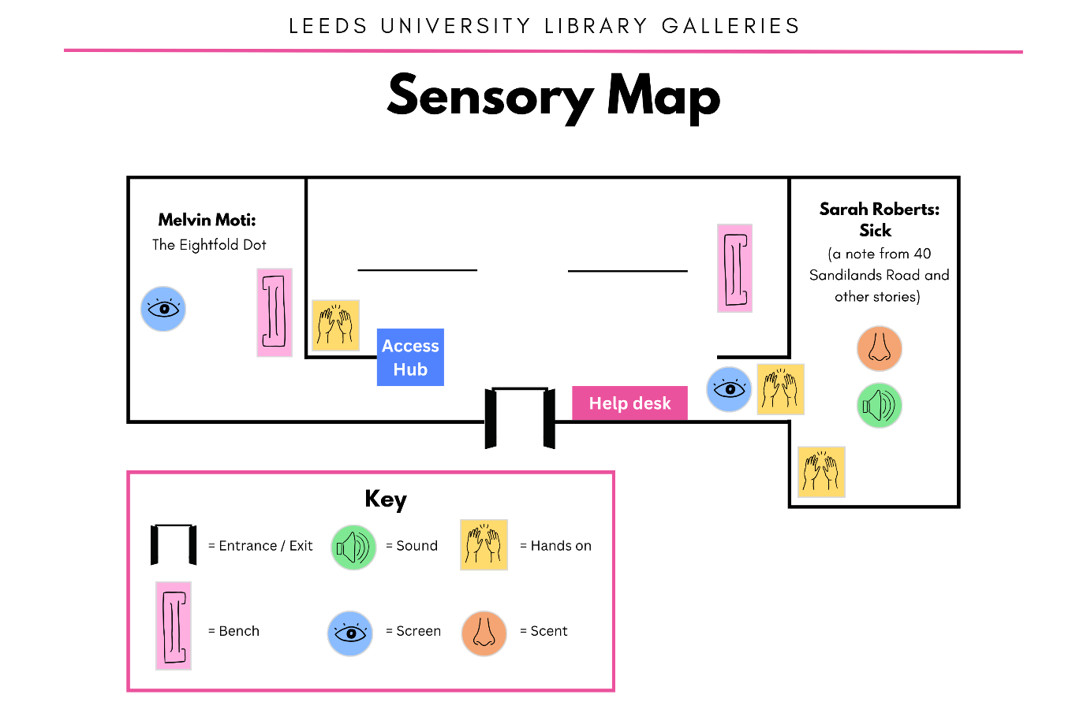

This may change based on what’s on.

You can borrow an up-to-date copy in the Gallery during your visit.

## Finding the Gallery

|  |  |
| --- | --- |
| The Stanley and Audrey Burton Gallery is in the Parkinson Building, University of Leeds.  This is a large, grey building with a big clock tower. | Photograph of the exterior of a large white stone building with columns and a tall square clock tower, against a pale blue sky. |
| You can get here on local transport or by car.  From the train station, it is a 30 minute walk. Or, ask for “Parkinson Steps’ on bus services 22, 23, 24, 25, 26, 27, 28, or 56. | Graphic of an aerial map with white roads on a grey background. Overlaid is a pale pink shape and black labels that read Universty of Leeds campus, To Headingley, and To Leeds City Centre and train station respectively. |
| There is no public parking on campus. We can book nearby parking for blue badge holders.  Please email or call before your visit to arrange. | Graphic of an aerial map with white roads on a grey background. Overlaid is a pale pink shape, a black label that reads Beech Grove Terrace (recommended), and various blue and white disabled parking signs dotted around. |
| The main entrance is up 22 steps, or the exterior accessible lift. | Photograph of a set of stone steps with two metal handrails, leading towards a set of three doors between stone pillars.Photograph of a white brick, rectangular structure with gold tile decoration on the side of a large stone building. Within the structure is a gold lift door. |
| Through the foyer, you will enter the Parkinson Court.  This large area is open to the public. | Photograph of an entrance foyer with beige tile flooring, and a wide glass doorway. Above the doorway is a sign which reads The Parkinson Building.Photograph of the interior of a tall large building with stone collumns around the walls, and a grand staircase at the back. A row of chandeliers hang from the ceiling. |
| Other parts of the building are not open to the public. For example, the Brotherton Library.  Staff and students can enter these areas with a pass. | Photograph of glass doors leading to a wooden reception desk. Above the doors is a sign which reads The Brotherton Library. |
| You can find the Gallery entrance underneath the pink banners in Parkinson Court. | Photograph of glass doors between four stone columns, which reach above the doors to a second floor balcony. Hanging between the columns are pink banners. Either side of the glass doors are standing banners in pink and white. |
| Follow the signs to find the glass doors. | Photograph of a grey wall with a large white and pink logo which reads The Stanley & Audrey Burton Gallery. Underneath the logo is a row of white arrows, point towards glass double doors.Photograph of a close up of glass doors with a standing banner either side. The banners are mostly pink and white with some illustrations. In front of the banner on the right is a standing sign with a pink arrow pointing towards the doors. |
| You can ask any member of staff for directions.  Find them at the Help Desk or Brotherton Library. | Photograph of a round wooden desk with a wooden pillar in the centre. In the background are stone columns and glass doors. Above the doors is a clock and a sign which reads The Brotherton Library. |

## Map of Parkinson Building

Copies of this map are available in the Gallery.

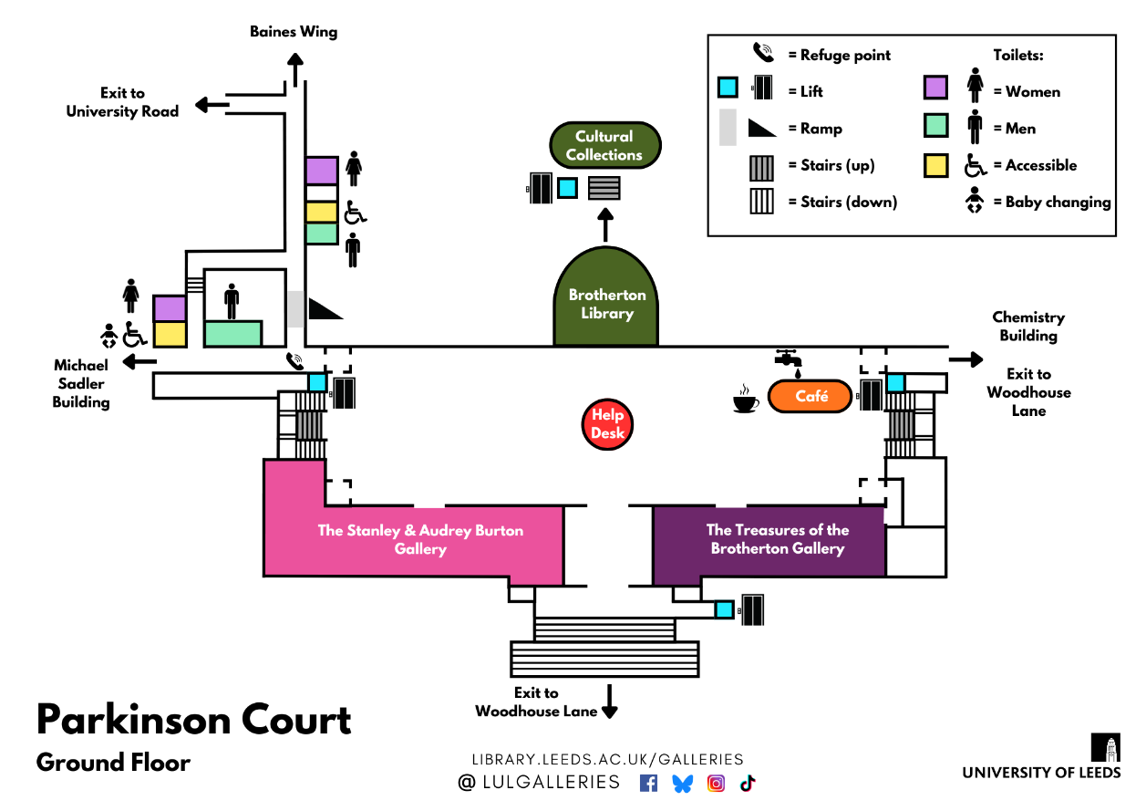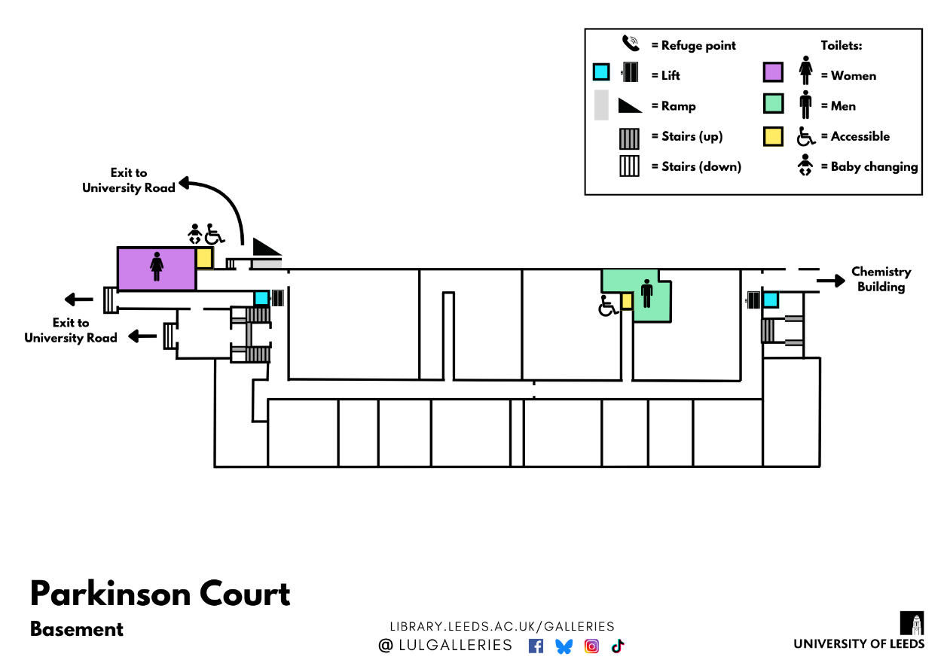

## When you arrive

|  |  |
| --- | --- |
| The glass doors will slide open.  A member of staff will greet you and say hello.  They don’t wear a uniform, but do wear a green lanyard. | Photograph of a person in leopard print dunagrees and a pink jumper, and wearing a green lanyard, smiling and waving from a room inside two open glass doors. |
| Staff will be sitting behind the desk. Sometimes they will walk around.  You can ask them for help, information or directions. | Photograph of two people sitting behind a white desk. The desk has illuminated shelves in the front full of books, and wooden sculptures on the wall behind. The two people are wearing green lanyards, and are smiling and waving. |
| They might ask you to complete a survey.  You can say yes or no.  You can tell them your answers, or fill out the survey yourself. | Photograph of a clipboard with a paper survey attached and a silver pencil, on a grey background. The survey has yellow bars across it indicating the different questions. |
| It is okay if you do not want to chat.  You can wear a red ‘Please leave me alone’ wristband and staff will respect your privacy. | Photograph of a close up hand wearing a green and red rubber bracelet. On the bracelet is white writing which reads Please leave me. |
| There is no cloakroom or lockers.  You will carry your coats and bags with you whilst exploring the gallery. | Photograph of a person stood in the middle of a white walled gallery room. The person is wearing a purple checkered backpack and a pink jumper, and is carrying a green coat over their arm. In the background are large colourful paintings and a grey bench. |
| Staff will ask you to leave your food or drink at the desk.  This is to protect the artworks. You can collect it at the end of your visit. | Photograph of a close up sign with black text which reads Please enjoy your food and drink outside the gallery, on a white background. The sign is resting on the top of a white suface. Next to the sign is a purple waterbottle with flower pattern, and a plastic tub of tiramisu. |

## Rules in the Gallery

|  |  |
| --- | --- |
| You cannot **touch** the artworks. | Black graphic of a hand in a circle with a line through it, on a grey background. |
| You cannot **eat** in the Gallery. | Black graphic of a cheeseburger in a circle with a line through it, on a white background. |
| You cannot **drink** in the Gallery. | Black graphic of a cup and straw in a circle with a line through it, on a grey background. |
| You cannot take photos **with flash.** | Black graphic of a camera on a white background. The camera has a flash on the top with a line through it. |
| These rules help to protect the artwork from any damage.  If you are not sure what you can and cannot touch, please ask a member of staff. | Black question mark on a grey background. |

## Things you can do in the Gallery

You can **look** at the artworks.

You can **sit** and **rest** on a bench, stool, or beanbag.

You can **read** the text panels.

You can **take photos** without flash**.**

You can touch some things.

For example, **write** a comment or **open** drawers.

You can **draw** or **write** with pencils.

You can **talk** to the staff and ask questions.

You can **relax** and **enjoy** the less busy atmosphere.

You can buy a souvenir from the gift **shop**.

You can **chat** about what you like and don’t like.

You can **take leaflets** from the desk.

You can stay for as long or as little time as you like.

## What will you see?

|  |  |
| --- | --- |
| The Stanley and Audrey Burton Gallery is a small gallery.  There are 3 rooms. | Photograph of the inside of a white walled gallery space with wooden laminate flooring. In the middle of the room is a white plinth with a black sulpture on top. Either side are white walls with colourful paintings. The back wall is also covered in a row of paintings. |
| The main room shows artworks from the University Art Collection.  The University looks after thousands of artworks. Around 1 out of 10 are on display. | Photograph of the inside of a white walled gallery room with wooden laminate flooring. Around all the walls is a row of artworks - some paintings and some black and white photographs in black frames. Next to the left wall is a glass case with a sculpture inside. |
| Two more rooms are for temporary exhibitions.  The displays change often. You might see something different every time you visit. | Photograph of the inside of a white walled gallery room with wooden laminate flooring. In the middle of the room is a grey bench. The back wall is covered in glass cases and rows of white drawers. Inside the cases are a series of artworks hung on the back wall, some black and white and some colourful. On the right wall is an illuminated glass case with shelves, and a doorway with a closed white door. |
| You will see different types of art, from the 17th century to today.  This might include drawings, paintings, sculptures, films and installations. | Photograph of a white walled corridor leading to a white walled gallery space, with wooden laminate flooring. On the walls of the corridor are hung various framed artworks. In the room beyond is a colourful hanging mobile with different coloured circles. |
| Every artwork has a label.  It tells you the title, who made it, and when. Some describe what it shows, or how it was made. | Photograph of a close up text label on the wall beside an artwork. The label has black writing on a white background. |
| You can pick out the things that interest you, in any order.  You can look at things as long or as little as you like. | Photograph of close up hands holding a rectangular magnifying sheet with black border, up to a text label on a white wall. |

## What can you borrow?

|  |  |
| --- | --- |
| There are items that are free to borrow to help enjoy your visit.  You can take anything off the ACCESSories Hub and use it in the Gallery. | Photograph of a wooden pegboard with various wooden shelves, holding things like pencils, fidget toys, pink and grey blankets, and a folder with pink text which reads Large Print Guide. In the background is the interior of a white walled gallery space with artworks on the walls. |
| You can borrow:   * Blankets * Coloured plastic overlays * Cushions * Ear defenders * Fidget toys * Large print guides * Magnifying glasses * Magnifying sheets * Maps of the building * Masks * Mood bands * Pencils with grips * Ramble tag * Reading windows * Sensory maps * Slow-looking prompts * Translations (Arabic and Chinese) * Visual story * Weighted lap pad * Weighted shoulder wrap * Yoga mats |  |
| Please return items here before you leave.  We will clean them for another person to use. | Photograph of a person putting a rectangular magnifying sheet back on the shelf of a wooden pegboard. On the other shelves of the pegboard are things such as rubber bracelets, magnifying glasses, ear defenders and yoga mats. Behing them are framed artworks on a white wall. |
| You can use items to help you:  Get info | Photograph of a person holding open a folder and reading the contents. The cover of folder has pink text which reads Large Print Guide. In the background is an orange and brown painting. |
| Get comfortable | Photograph of a person in leopard print dungarees sat on a grey bench. On their lap is a navy blue weighted blanket. |
| Get exploring | Photograph of a close up hand holding up a magnifying glass. In the background is a large colourful painting of anglels. |
| Get creative | Photograph of close up hands holding a clipboard and pencil, and sketching bears on white paper. |

## Seating

|  |  |
| --- | --- |
| In the Gallery, you can sit and rest on a bench, stool, or beanbag.  You can find metal benches around the Gallery. | Photograph of a grey bench in the middle of room with wooden laminate flooring. On the bench is a large open book. |
| There are two sets of stools.  You can take a stool and sit anywhere in the Gallery. | Photograph of a black folding stool stood on a wooden laminate floor. Behind the stool is a stand holding more black stools, and the corner of a white desk with illuminated bookshelves. |
| You can ask a member of staff for a chair with a back.  We can help you move the chair. You can sit anywhere in the Gallery. | Photograph of a person sat on a white chair looking at a hanging mobile in the middle of a white walled room. The mobile has colourful circles. |
| You can ask a member of staff for a beanbag.  You can sit on the beanbag anywhere in the Gallery. | Photograph of a person in a green jumper sat on a pink beanbag. They are looking up at a row of artworks hung on a white wall. |
| There are lots more seats outside the Gallery.  You can sit at a wooden bench or a table. | Photograph of a wooden table with wooden benches either side, on a wooden parquet floor. In the background are stone columns, and glass doors. |
| Outside the Gallery, you can eat and drink. There is also a café with more seating.  It can be more busy and noisy than the Gallery. | Photograph of rows of square tables with green and white chairs, on wooden parquet floor. In the background is a curved wooden cafe counter and a wide staircase at the back of the room. |

## Eating and drinking

|  |  |
| --- | --- |
| You cannot eat or drinkinside the Gallery. | Two black graphics on a grey background. On the left is a cheeseburger in a circle with a line through it. On the right is a cup and straw in a circle with a line through it. |
| There are lots of seats outside the Gallery.  You can bring your own food and drink to eat here. | Photograph of a wooden bench and a pot plant underneath a large window. Beyond the window are red brick buildings. |
| There is also a café with tables and seats, at the opposite end of the hall.  This is the Parkinson Court Café. | Photograph from above of rows of square tables with white and green chairs, on a wooden parquet floor. At the far side of the room are stone columns and a curved cafe counter. |
| The café sells a range of sandwiches, snacks, and hot and cold drinks.  You can pay with cash or card. | Photograph of a close up wooden cafe counter with glass refrigerated section containing drinks and sandwiches. In a basket on the front are packets of crisps. |
| The café is open:  Monday  Tuesday  Wednesday  Thursday  Friday | Graphic of a page from a wall calendar with a red top and black writing which reads Monday - Friday, on a grey background. |
| The café is open from  8.30am to 3.00pm.  It can be busy and loud during lunch times. | Two black graphics of clock faces on a white background. The arrow hands on the clock on the left show half past eight The arrow hands on the clock on the right show three o'clock. |

## Finding the bathrooms

|  |  |
| --- | --- |
| In the basement of Parkinson Building, there are mens’, ladies’ and gender neutral accessible toilets.  They are open for the public to use. | Two photographs of wooden doors. The photograph on the left shows two wooden doors, one with a wheelchair symbol and one with a nam symbol. The photograph on the right shows double doors with glass windows under a sign which reads Ladies Toilets |
| To find the toilets, exit the Gallery and turn left towards the steps. | Photograph of a room with wooden parquet flooring, stone columns, and three big windows on the back wall. On the left of the image is a pink and white standing banner. On the right is a pot plant. Overlaid in the centre of the image is a white arrow pointing left.Photograph of the inside of a large room with wooden parquet flooring and stone columns, and a grand staircase at the back. In the middle of the image is a triangular pink and white standing banner. Overlaid is a white arrow pointing back towards the stairs. |
| Walk down 22 steps to the basement, or use the accessible lift. | Photograph of the top of a staircase next to a lift. Overlaid on the photograph is a white arrow pointing down the stairs, and a white wheelchair symbol with arrow pointing down over the lift door. |
| You will see a room full of computers in front of you.  For the **ladies’** bathrooms, turn left, and left again. | Two photographs of corridors with wooden parquet flooring. The photograph on the left shows a narrow corridor with windows into offices down one side, and overlaid at the end of the corridor is a white arrow pointing left. The photograph on the right is a wider corridor with an automatic door on the right wall and double doors at the end, with a white arrow overlaid pointing towards the double doors. |
| For the **mens’** bathrooms, turn right, then left.  Continue down the corridor until you reach the toilets on your left. | Photograph of a corridor with windows into offices down the left wall and overlaid at the end a white arrow pointingleft.Photograph of a wooden double door, the left door propped open, leading to a long corridor with blue lockers down the right wall. Overlaid in the doorway is a white arrow pointing down the corridor.Photograph of the corner of two corridors with wooden parquet flooring and white walls. Overlaid is a white arrow pointing to the left corridor. |
| There is a **wheelchair accessible**, **unisex** toilet outside both bathrooms.  **Baby changing** facilities are available in the accessible toilet outside the ladies’ bathroom. | Three black graphics on a white background. The top left graphic is a person in a wheelchair. The top right graphic is a symbol of a woman and a symbol of a man with a vertical line between them. The bottom graphic is a baby laid on its back on a horizontal line, with a person leaning over them. |

## Accessible bathrooms

|  |  |
| --- | --- |
| The nearest **right-hand transfer** bathroom is in the Basement.  The nearest **left-hand transfer** bathroom in on the Ground Floor. | Two black and grey graphics on a grey background. The top graphic is a wheelchair next to a toilet with a green arrow pointing from left to right. The bottom graphic is a toilet next to a wheelchair with a green arrow pointing from right to left. |
| To find the bathroom, see the map on Page 10.  Look for this yellow symbol.  Some also have baby-changing facilities. | Black graphic on a yellow background of a person in a wheelchair. |
| All accessible bathrooms have step-free access via lift.  You do not need a RADAR key. | Two black graphics on a grey background. The left graphic is a person in a wheelchair inside a square with two arrows, one pointing up and one pointing down, on top. The right graphic is a key with a blue heart which reads RADAR, with a line through it. |

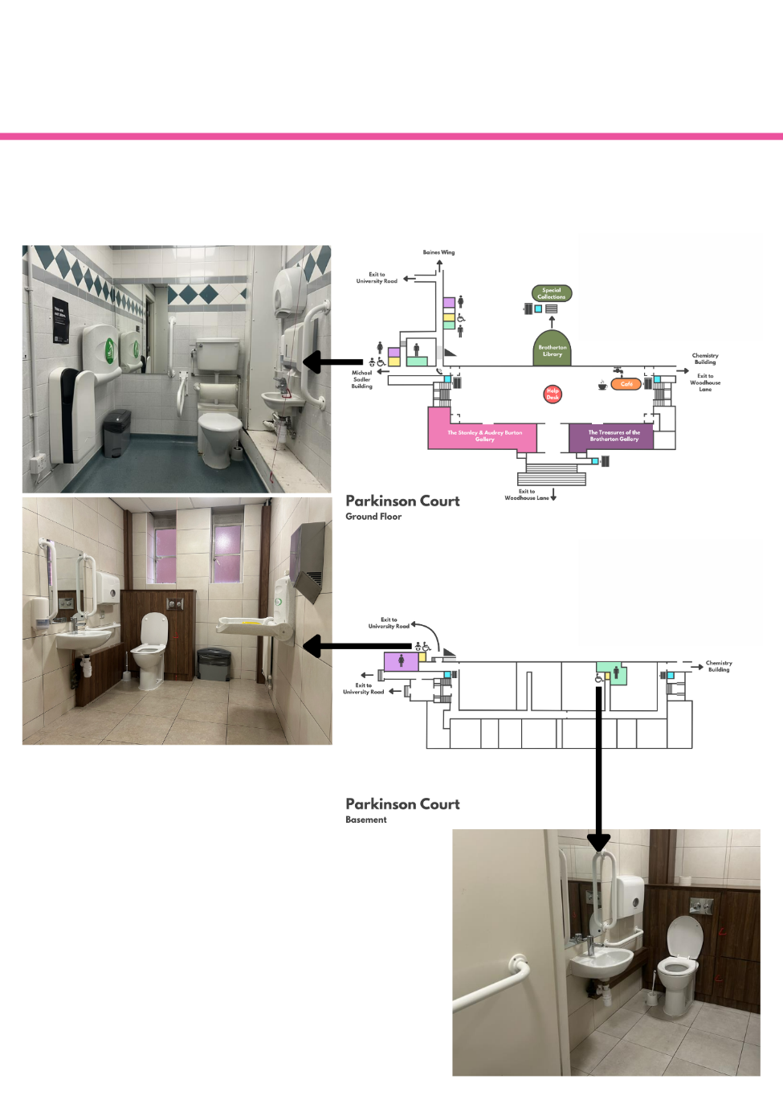

Find a copy of this map on Page 10.

We can provide further details of the dimensions and facilities.

## If you hear the fire alarm

|  |  |
| --- | --- |
| In the unlikely event of a fire, a loud continuous alarm will sound.  If you hear this alarm, you should immediately evacuate the building by the nearest exit. | Black graphic over a grey background of a bell with four curved lines to indiciate noise. |
| All staff are trained to assist in case of an emergency.  Please follow staff instructions and leave the Gallery. Ask for help if you need. | Photograph of a green sign above a doorway. On the sign is a white graphic of a running man, and a white arrow pointing to a white rectangle. |
| Follow the green signs to exit the building.  Wait on the grass opposite the Parkinson Steps until it is safe to return inside. | Photograph of a tree in the middle of a triangular patch of grass between roads. The road nearest has yellow markings which read Bus Stop. In front of the tree is a row of bike racks. Behind the tree are two tall church spires. |

## Shop

|  |  |
| --- | --- |
| There is a small shop in the Gallery.  You can buy souvenirs, like books, postcards, greeting cards, pencils or tote bags. | Photograph of a white shelving unit covered in rows of postcards. Above the shelves hangs a pink tote bag with two white squiggly lines. |
| The shop is cashless. You can only pay by card or contactless. | Two black graphics on a grey background. The graphic on the left shows a hand holding a debit card over a chip and pin machine. The right graphic shows two paper notes of money in a circle with a line through it. |
| You don’t have to buy anything.  You can also buy most items after your visit, on the online shop. | Photograph of two illuminated shelves displaying types of books. |

## Leaving the Gallery

|  |  |
| --- | --- |
| When you leave the Gallery, a member of staff will thank you.  You can exit the building the same way you entered. | Photograph of a wide glass doorway next to a white desk. Behind the desk is a person wearing a green lanyard, smiling and waving. |
| You can take leaflets from the desk. They tell you about exhibitions and events.  You can sign up to the mailing list. You will receive regular emails. | Photograph of close up leaflet stands resting on a white desk, filled with leaflets advertising events, Public Art Trails and What's On. In front of the leaflets is a black QR code on a white sign with black text which reads Keep up to date wth the Galleries |
| Before you go, you can ask any questions about finding your way to our other Gallery, around the University, or the local area.  If you enjoyed your visit, or had any problems, you can share any feedback with them. | Photograph of two people stood either side of a wide countertop. The person on the right is holding a clipboard and pencil, and filling out survey questions whilst smiling. The person on the right is smiling back at them. |

## Contact us

Please talk to us if you have queries or need any help in advance of your visit.

We can answer calls and emails Tuesday to Saturday, 10.00am to 5.00pm.

On the day of your visit, our Visitor Services Team will be available to help.

Website: library.leeds.ac.uk/Galleries

|  |  |
| --- | --- |
| Phone: 0113 343 2778 | Black graphic on a white background of a telephone in a circle. |
| Email: gallery@leeds.ac.uk | Black graphic on a white background of an envelope in a circle. |
| Social media: @LULGalleries | Four icons in a row. Left to right: a white letter f in a dark blue square, a blue butterfly, a yellow, red and purple polaroid camera, and a black, red and blue music note. |